Adam Mohmoud
AZ-900 Fundamentals
Azure Key Vault Lab
Mohmoud.adam@gmail.com

In this lab I created an Azure Key Vault involves setting up a secure and centralized service to manage cryptographic keys, secrets, and certificates, enhancing data protection and simplifying key and secret management in Azure applications and service.
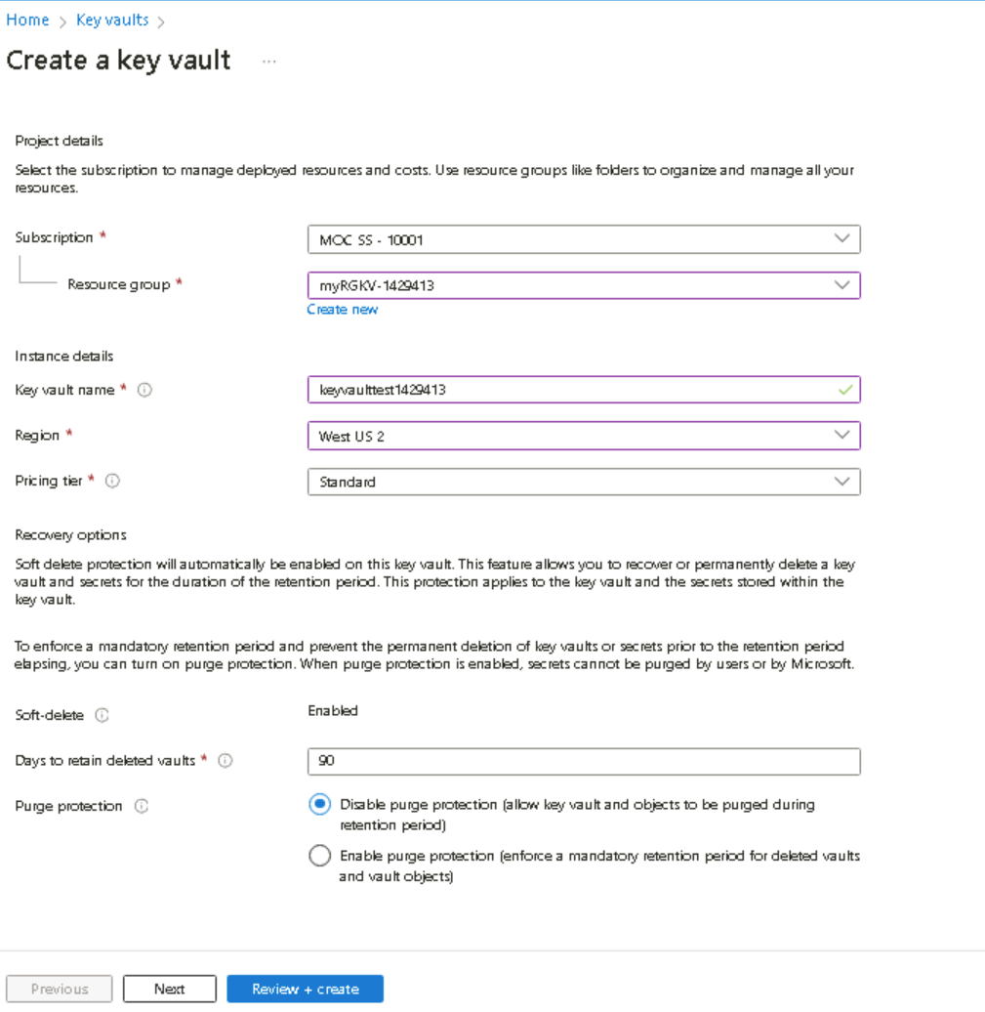
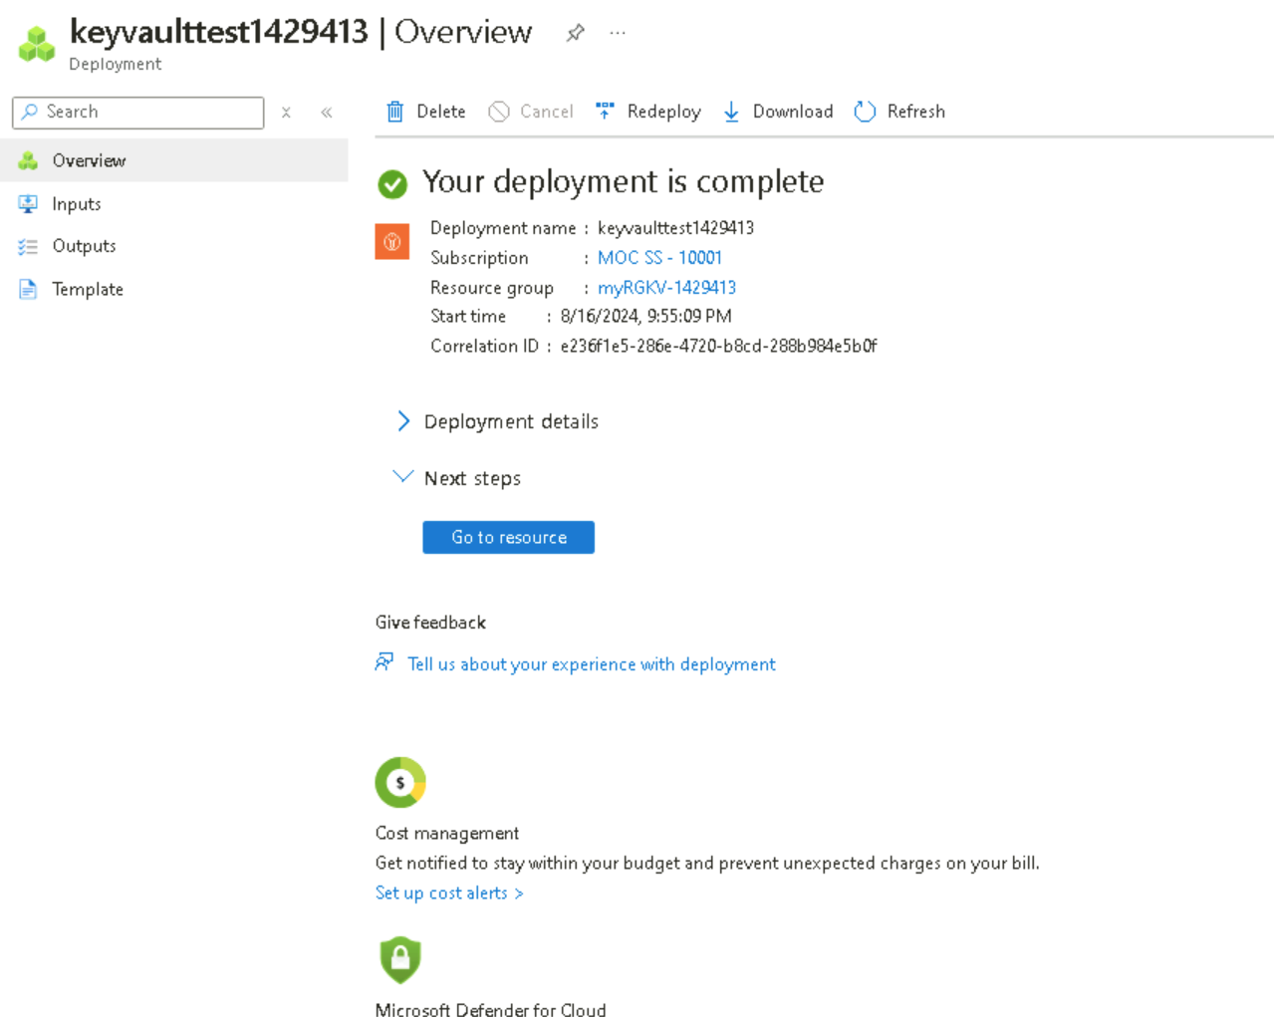
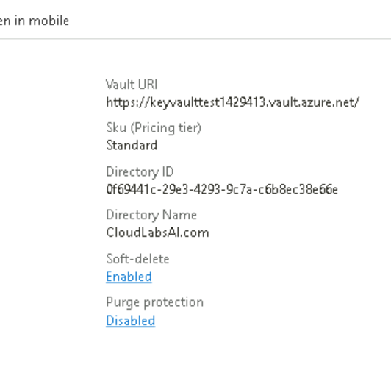
I clicked on the key vault ‘Overview’ tab and took note of the Vault URI. Applications that use your vault through the REST API will need the URI. In the key vault options, under ‘objects’ you can review Keys, Secrets, Certificates.

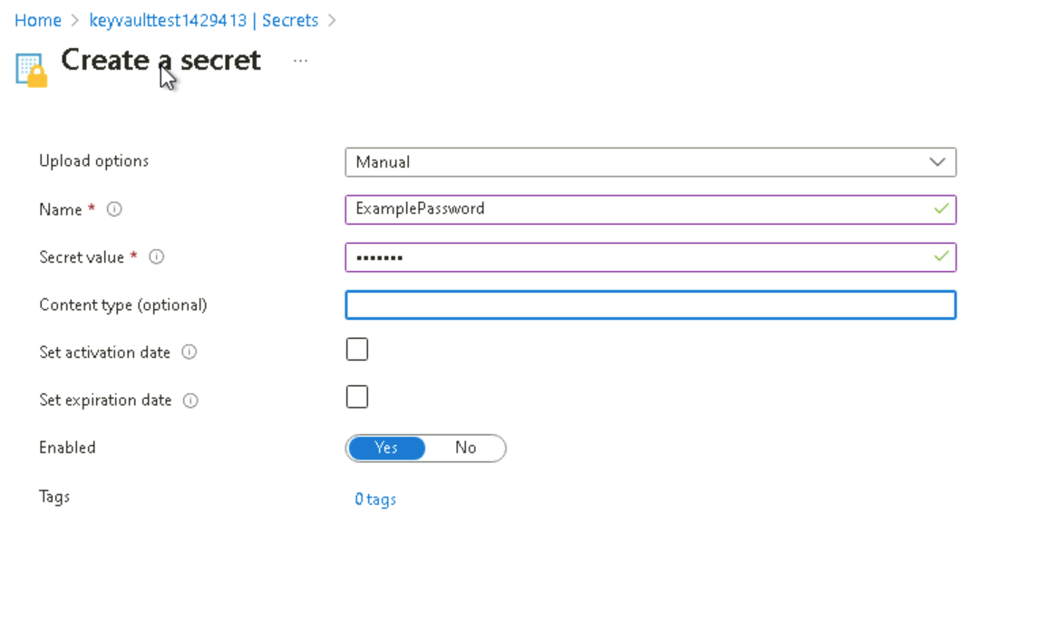

Here I configured the ‘secret’. Notice you can set an activation and expiration date and disable the secret.
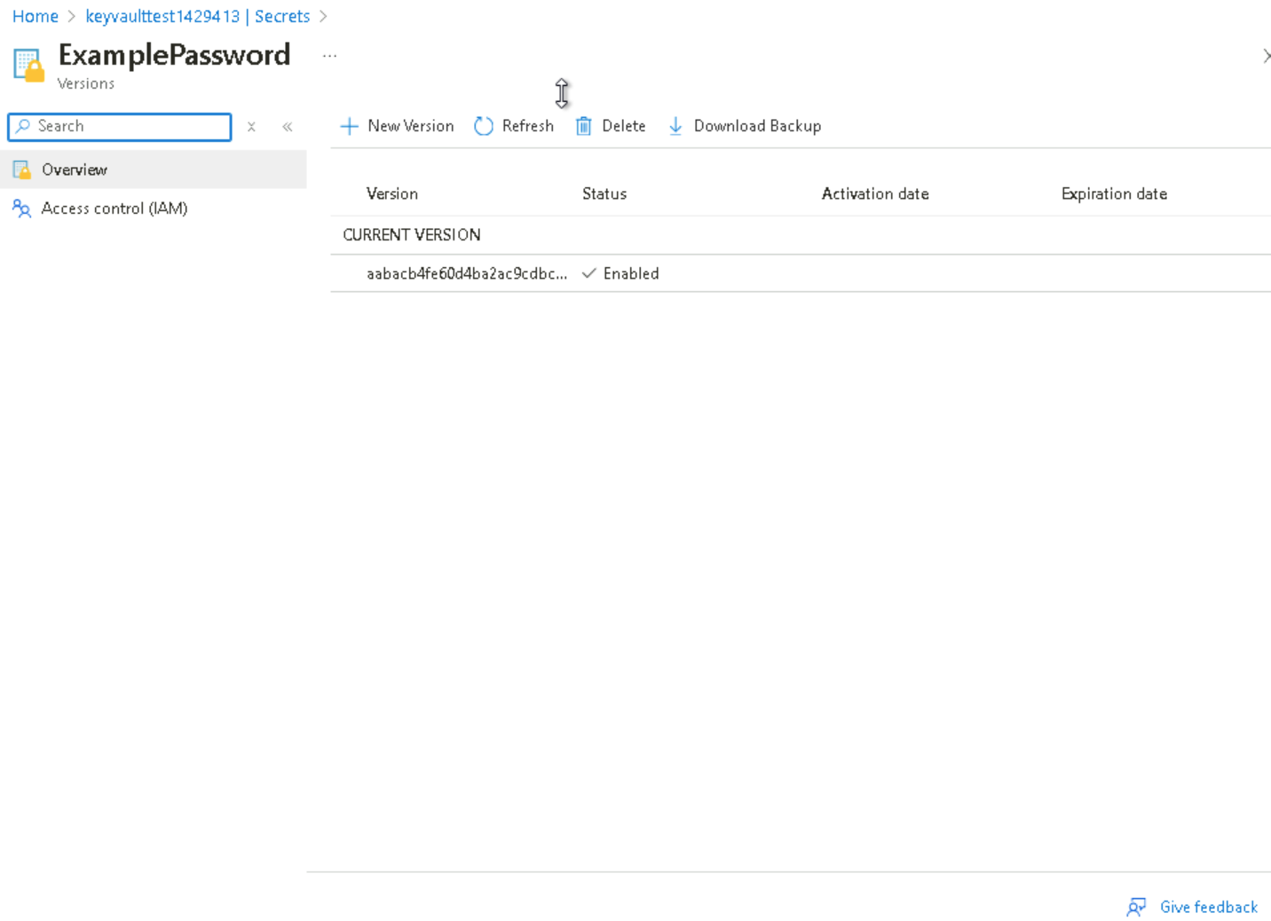
Once ‘ExamplePassword’ secret is listed the status should be enabled. Select the ExamplePassword secret and click the current version.
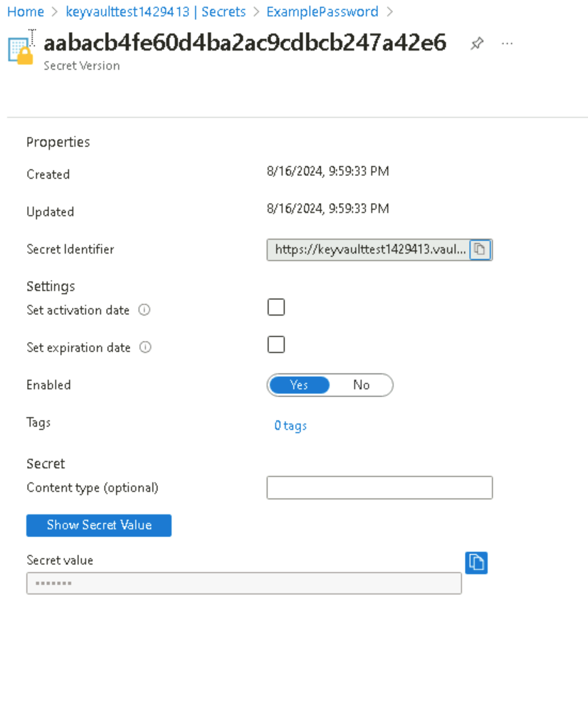
Under properties, the Secret Identifier information bar, is a URL value that can now be used with applications. It provides a centrally managed and securely stored password. If I click the button ‘Show Secret Value’, under Settings to display the password specified earlier.
